

**Tribhuvan University**

**Faculty of Humanities and Social Sciences**

**Lab Report of Computer Graphics**

**Submitted to**

**Department of Computer Application**

**Shahid Smarak College**

Submitted by**:**

**Name: Amir Maharjan**

**Tu Registration Number: 6-2-262-3-2020**

Under the Supervision of

**Shaya Adhikari**

**Table of Contents**

**1. Program to implement DDA Line Drawing Algorithm:** 1

**2. Program to draw a circle using Midpoint Algorithm:** 3

**3. WAP to implement bresenham’s line drawing algorithm.** 7

**4. Program to implement 2D reflection code** 11

# 

# **1. Program to implement DDA Line Drawing Algorithm:**

#include<graphics.h>

#include<conio.h>

#include<stdio.h>

void main()

{

intgd = DETECT ,gm, i;

float x, y,dx,dy,steps;

int x0, x1, y0, y1;

initgraph(&gd, &gm, "C:\\TC\\BGI");

setbkcolor(WHITE);

x0 = 100 , y0 = 200, x1 = 500, y1 = 300;

dx = (float)(x1 - x0);

dy = (float)(y1 - y0);

if(dx>=dy)

{

steps = dx;

}

else

{

steps = dy;

}

dx = dx/steps;

dy = dy/steps;

x = x0;

y = y0;

i = 1;

while(i<= steps)

{

putpixel(x, y, RED);

x += dx;

y += dy;

i=i+1;

}

getch();

closegraph();

}

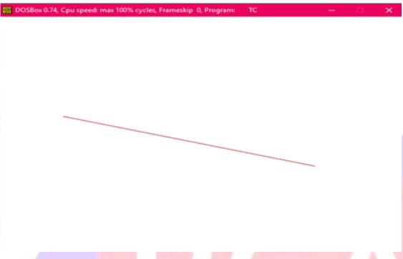

# **2. Program to draw a circle using Midpoint Algorithm:**

#include <graphics.h>

#include <stdlib.h>

#include <math.h>

#include <stdio.h>

#include <conio.h>

#include <iostream.h>

#include <stdio.h>

#include <graphics.h>

void drawCircle(int xc, int yc, int radius) {

int x = radius;

int y = 0;

int err = 0;

// Open a graphics window

initwindow(400, 400, "Circle Drawing");

// Plot the initial point in each quadrant

putpixel(xc + x, yc - y, WHITE);

putpixel(xc - x, yc - y, WHITE);

putpixel(xc + y, yc + x, WHITE);

putpixel(xc - y, yc + x, WHITE);

while (x >= y) {

y++;

// Mid-point is inside or on the perimeter

if (err <= 0) {

err += 2*y + 1;

}

// Mid-point is outside the perimeter

else {

x--;

err += 2 * (y - x) + 1;

}

// All the perimeter points have already been printed

if (x < y) {

break;

}

// If the generated point is on the line x = y, then

// the perimeter points have already been printed

if (x != y) {

putpixel(xc + x, yc - y, WHITE);

putpixel(xc - x, yc - y, WHITE);

putpixel(xc + y, yc + x, WHITE);

putpixel(xc - y, yc + x, WHITE);

}

// If the generated point is on the line x = y, then

// the perimeter points have already been printed

if (x != y) {

putpixel(xc + y, yc - x, WHITE);

putpixel(xc - y, yc - x, WHITE);

putpixel(xc + x, yc + y, WHITE);

putpixel(xc - x, yc + y, WHITE);

}

}

delay(5000); // Display the window for 5 seconds before closing

closegraph(); // Close the graphics window

}

int main() {

int xc, yc, radius;

// Get center and radius input from the user

printf("Enter the center (x y): ");

scanf("%d %d", &xc, &yc);

printf("Enter the radius: ");

scanf("%d", &radius);

// Call the function to draw the circle

drawCircle(xc, yc, radius);

return 0;

}

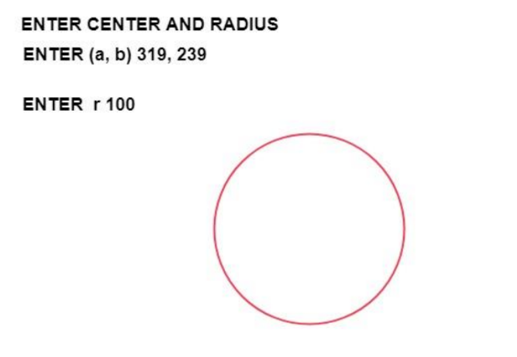

# **3.WAP to implement bresenham’s line drawing algorithm.**

#include <stdio.h>

#include <graphics.h>

void drawLine(int x1, int y1, int x2, int y2) {

// Open a graphics window

initwindow(400, 400, "Bresenham's Line Drawing");

int dx = abs(x2 - x1);

int dy = abs(y2 - y1);

int twoDy = 2 * dy;

int twoDx = 2 * dx;

int twoDyMinusDx = 2 * (dy - dx);

int twoDxMinusDy = 2 * (dx - dy);

int decisionParameter;

int x, y, xEnd;

// Determine the initial decision parameter and starting point

if (dx > dy) {

if (x1 > x2) {

x = x2;

y = y2;

xEnd = x1;

} else {

x = x1;

y = y1;

xEnd = x2;

}

putpixel(x, y, WHITE);

decisionParameter = twoDy - dx;

} else {

if (y1 > y2) {

x = x2;

y = y2;

xEnd = x1;

} else {

x = x1;

y = y1;

xEnd = x2;

}

putpixel(x, y, WHITE);

decisionParameter = twoDx - dy;

}

// Plot the line

while (x < xEnd) {

x++;

if (decisionParameter < 0) {

decisionParameter += twoDy;

} else {

if (dx > dy) {

if ((x2 - x1) > 0) {

y++;

} else {

y--;

}

} else {

if ((y2 - y1) > 0) {

x++;

} else {

x--;

}

}

decisionParameter += twoDyMinusDx;

}

putpixel(x, y, WHITE);

}

delay(5000); // Display the window for 5 seconds before closing

closegraph(); // Close the graphics window

}

int main() {

int x1, y1, x2, y2;

// Get the coordinates of the two endpoints from the user

printf("Enter the coordinates of the first point (x1 y1): ");

scanf("%d %d", &x1, &y1);

printf("Enter the coordinates of the second point (x2 y2): ");

scanf("%d %d", &x2, &y2);

// Call the function to draw the line

drawLine(x1, y1, x2, y2);

return 0;

}

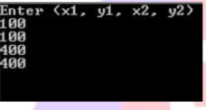

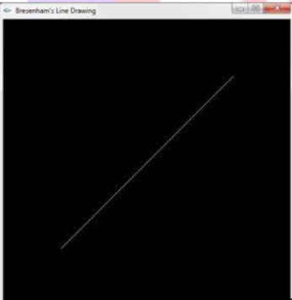

# **4.Program to implement 2D reflection code**

#include <conio.h>

#include <graphics.h>

#include <stdio.h>

{

// Initialize the drivers int gm, gd = DETECT, ax, x1 = 100; int x2 = 100, x3 = 200, y1 = 100; int y2 = 200, y3 = 100;

// Add in your BGI folder path

// like below initgraph(&gd, &gm,

// "C:\\TURBOC3\\BGI");

initgraph(&gd, &gm, "");

cleardevice();

// Draw the graph

line(getmaxx() / 2, 0, getmaxx() / 2, getmaxy());

line(0, getmaxy() / 2, getmaxx(), getmaxy() / 2);

// Object initially at 2nd quadrant

printf("Before Reflection Object" in 2nd Quadrant");

// Set the color

setcolor(14);

line(x1, y1, x2, y2);

line(x2, y2, x3, y3);

line(x3, y3, x1, y1);

getch();

}

// After reflection

printf("\nAfter Reflection");

// Reflection along origin i.e.,

// in 4th quadrant setcolor(4);

line(getmaxx() - x1, getmaxy() - y1, getmaxx() - x2, getmaxy() - y2);

line(getmaxx() - x2, getmaxy() - y2, getmaxx() - x3, getmaxy() - y3);

line(getmaxx() - x3, getmaxy() - y3, getmaxx() - x1, getmaxy() - y1);

// Reflection along x-axis i.e.,

// in 1st quadrant

setcolor(3);

line(getmaxx() - x1, y1,getmaxx() - x2, y2);

line(getmaxx() - x2, y2,getmaxx() - x3, y3);

line(getmaxx() - x3, y3, getmaxx() - x1, y1);

// Reflection along y-axis i.e.,

// in 3rd quadrant

setcolor(2);

line(x1, getmaxy() - y1, x2, getmaxy() - y2);

line(x2, getmaxy() - y2, x3, getmaxy() - y3);

line(x3, getmaxy() - y3, x1, getmaxy() - y1);

getch();

// Close the graphics

closegraph();

